How to activate the application with the activation code
To activate the application:
- In the application window, click License: ... days remaining.
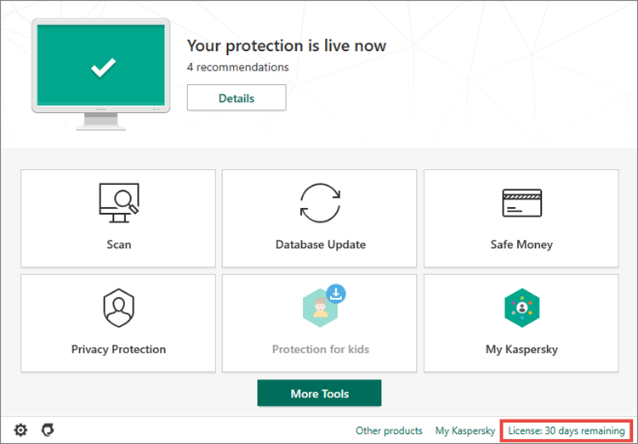

- Click Enter activation code.
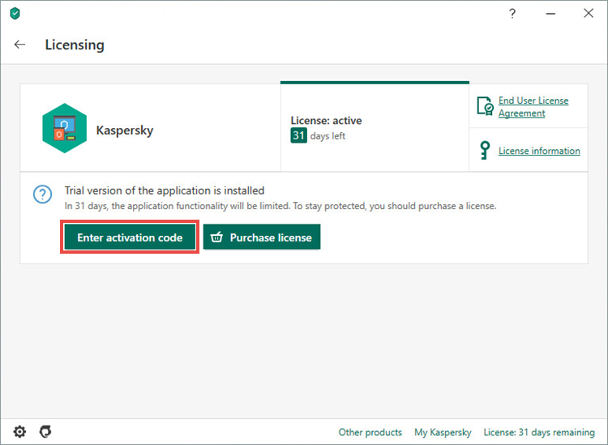
- Enter the code from the message you have received after buying the license and click Activate.
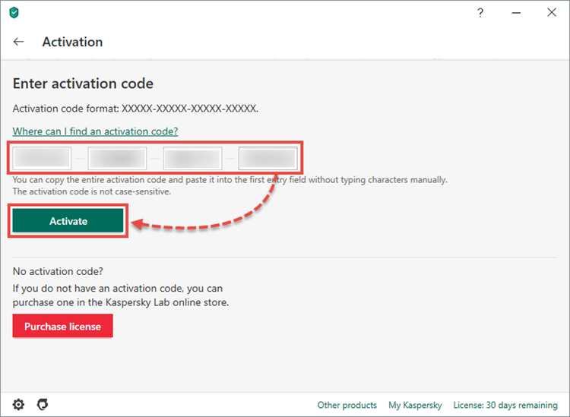
- Click Done.
Kaspersky Internet Security has now been activated.
If you purchased a license for multiple devices, activate Kaspersky Internet Security on all the devices using the same activation code.

